Kendriya Vidyalaya Sangathan
Summative Assessment- II, KurnoolCluster
No. of pages:5
Class: V sec: ______ Sub: Maths Time: 2 hrs.
Name of the Student: ____________________ RollNo: __
Sign of Invigilator: ________ Max Marks : 60

Competency | FN(15) | UBC(15) | AC(15) | PSA(15) | Total(60)
Value points Obtained
Grade Obtained
Signature of the Evaluator: ________
Formation of Numbers(15)
I. Complete the following. (1X5=5)1) Write the number name for30.214 = ___________________________________ 2) 50 paise = Rs. ______3)Write the number for tally mark = ____4)1 cm on the map = 200km on the ground, then 4cm on the map = ____cm on the ground.5)1Litre = _____ml.II.1) Draw the floor map of your house. (5x2=10)

2) Guessthe area of the following and put a √
Name of the thing | Square cm | Square meter | Square km
Handkerchief
Sari
Total land of the city
Indian flag
3) Halfof metre = _____cm
Half of kg = ________ grams.
4) Find the product. 200 × 12

5) 969 ÷ 4

Understanding Basic Concepts (15)
I.1) Find the area of the following shape. (1x5=5)

4cm _______ sq.cm

6cm
2) 785x0 = ___
3)The sum of the lengths of all sides of a closed shape is known as _______________
4)The unit of volume is ______________ (square unit, cubic unit).
5) The space occupied by any object is called as _________________

II.1) Onekg of onions becomes 100 gm when the water inside dries up,(3x2=6)
then half kg onions becomes ______ gm.
2) Tick the correct deep drawings of the cube.√
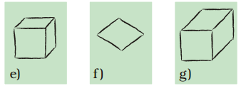
3) Total number of faces of a cube ______
Total number of corners of a cube _____
III. 1) Look at the map and answer the questions. (1x 4 = 4)

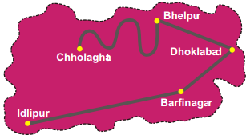
1) What is the difference between Idlipur and Barfinagar? _____cm
2) How many km will you have to travel if you go from Idlipur to Barfinagar? __km
3) Measure the distance between Chholghat and Bhelpur (use thread) _____cm
4) There is a place called Samosapur midway between Idlipur and Barfinagar. Mark it as S’
Ability to Compute(15)
I).1)How many sides are there in Central Hexagon?_____(1x3=3)
2) Measure the length of the following.

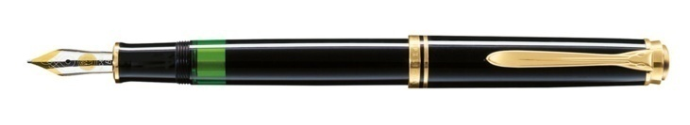_____cm _____mm
3) 50 paise = RS. ______

II)1) Match these.(2 x 4 = 8)
Rupee 3/4
99 paise
Rs.0.99
RRr

Rupee 99/100
25 paise
Rs.0.75

Rupee 1/4
75 paise
Rs.0.25
2) Complete the following table.
Name of greeting card holder | Length | width | Area (sq.cm) | Perimeter (cm)
SANIA | 10cm | 8cm | -------- | 36cm
AARUSHI | 11cm | 11cm | 121cm | -------
3) Look at the smart chart and find out.
Chiidren
who like
Children coffee
Who like
MilkChildren
who like
tea

- Children who like coffee -- 1/2,3/4,1/4 (Tick √ )
- Children who like milk -- 1/4,3/4.1/2 ( Tick √ )
4) Use Bela’s method to multiply these numbers.
32 X 21

III.Observe the table and answer. (1x4=4)
State | Salary for one day
Haryana | Rs.135
Rajasthan | Rs.73
Madhya Pradesh | Rs.97
Orissa | Rs.75

- Which state has fixed the highest amount? ___________
- Which state has fixed the lowest amount? ____________
- What is the difference between the salary of Madhya Pradesh and Orissa for one day? Rs. _______
- Neelam is a farm worker in Rajasthan; if she works 10 days how much salary did she get? Rs. ______

Problem Solving Ability(15)I. 1) 9000÷ 9 = ____ (1x3=3)
2) 11 x 11 = _______
3)How hours are there in two days? _______
II.1)Match these. (4 x 2 =8)
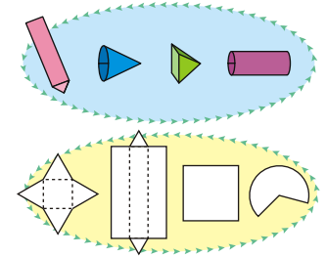

2)Measure the length of this lady’s finger.
____cm ____mm
3) The cost of 1penis Rs.6.50, what is the cost of 2 pens? Rs. ______

4) If 1metre =100cm, then 1cm=

III.Observe the following and answer. (1x4=4)

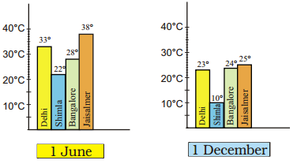

- Which city is the hottest on 1 June? ______________
- Which city is the coolest on 1 December? _____________
- Which city shows little changes in temperature on the two days --
1 June and 1 December ______________
- What is the temperature of Jaisalmer on 1 June? ______________

