KENDRIYA VIDYALAYA SANGATHAN
SUMMMATIVE ASSESSMENT – 2, KURNOOL CLUSTER
CLASS: V Max marks: 60
SUBJECT: E V S Time: 2 Hrs.
NAME:______________________________ ___ SEC: ____ ROLL NO:____
Competency | Observation (20) | Identification (20) | Discovery of Facts (20) | Total (60)
Value points
Grades

Signature of the invigilator: signature of the evaluator:
OBSERVATION: 20 VP
- Very Short Answers: 7 X 1 = 7 VP
Read the following and write the correct answers in the given blanks
- Solar energy is a _______________.
- _____________ is famous in Jammu and Kashmir.
- The shortage of water and food results in __________.
- Hot air is _________ and old air is _____________.
- Expand NBA ___________________________.
- The Architecture of our constitution _______________.
- Compost is a ___________ fertilizer.
- Short Answers: 2 x 4 = 8 VP
- Draw how the seed travels from field to plate in the given
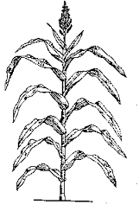
- Why do forests disappear? Give any two reasons.
________________________________________________________________________________________________________________________________________________________________________________________________________________________________________________________

- What do people do in the villages to earn money? Give any two examples.
________________________________________________________________________________________________________________________________________________________________________________________________________________________________________________________

- Write any four indoor and outdoor games in the given place:

Indoor games  1._____________________  2._____________________  3._____________________  4._____________________ | Outdoor games  1._____________________  2._____________________  3._____________________  4._____________________

III. Long Answer: 5 x 1 = 5 VP
- What should we do when there is an earthquake ?
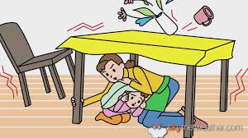
_____________________________________________________________________________________________________________________________________________________________________________________________________________________________________________________________________________________________________________________________________________________________________________________________________________________________________________________________________________________________________________________________________________________________________________

IDENTIFICATION: 20VP
VSA :5x1=5 vp
- Identify and name the pictures given below :

- Name the Musical instruments
____________________ ___________________________

- Find out our National game and put a [ √] tick mark from the following :
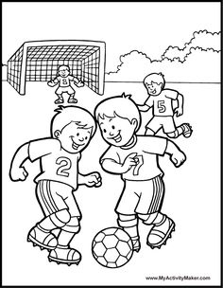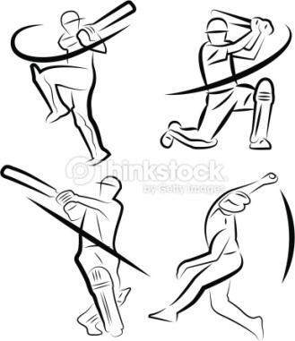
( ) ( ) ( ) ( )

- Identify and name the professions given below :
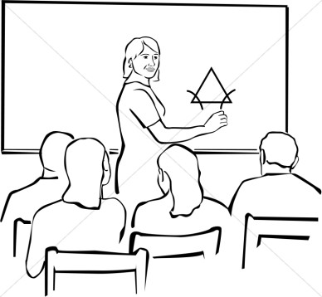
___________________ _______________________
WriteTrue or False:
- Roots do not need air to breathe [ ]

- Polio is inherited from family members [ ]

II. Short Answers: 5 X 2 = 10 VP
- What does a seed need to grow ?
________________________________________________________________________________________________________________________________________________________________________________________________________________________________________________________

- Observe the pictures and identify and write the name of the fuel used for these :
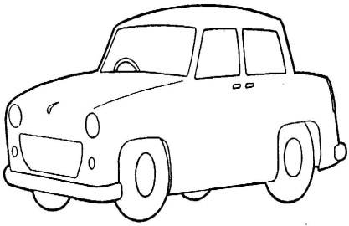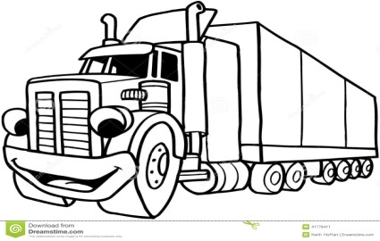
_____________________ _____________________

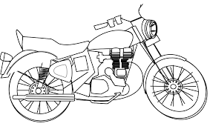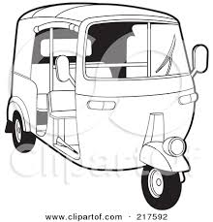
_____________________ _____________________
Identify this pictures and write about this :

3.
a) What is this? _____________
b) Why is itgiven ? _________________

4.
a) Who is she? _______________
b) She is a ___________________

Fill in the blanks with correct answers:
5. a) ______________ is a cone shaped tent.
b) Harvesting festivals are _________ and _________
III. Long Answer: 5 X 1 = 5 VP
I. Differentiate between ‘Modern farming’ and ‘Traditional farming’:
Modern farming  -----------------------------------------  -----------------------------------------  -----------------------------------------  -----------------------------------------  -----------------------------------------  -----------------------------------------  -----------------------------------------  -----------------------------------------  -----------------------------------------  -----------------------------------------  ----------------------------------------- | Traditional farming  -------------------------------------  -------------------------------------  -------------------------------------  -------------------------------------  -------------------------------------  -------------------------------------  -------------------------------------  -------------------------------------  -------------------------------------  -------------------------------------  -------------------------------------

DISCOVERING FACTS: 20VP
I. Very Short Answers: 5 X 1 = 5 VP
1. We use _____________ to listen the sound of heart beat.
2. Sunita Williams spent more than ____________in a __________.
3. Jatryabhai has to pay for the _______, ______, ________,__________.
4. Forest people are called _______________.
5. Write any two reasons for taking loan from the banks
__________________________ _______________________________
II. Short Answers: 5 X 2 = 10 VP

1. What is ‘Pulse polio’ ?
________________________________________________________________________________________________________________________________________________________________________________________________________________________________________________________________________

2. What would happen if nobody cleansthe garbage lying outside of your house or in a school ?
________________________________________________________________________________________________________________________________________________________________________________________________________________________________________________________________________

3. Why do people in ‘Leh’ dry the fruits and vegetables?
______________________________________________________________________________________________________________________________________________________________________________________________________

4. Write the effects of cutting down the forests ?
__________________________________________________________________________________________________________________________________________________________________________________________________________________________________________________________________________________________________________________________________________
5. Draw the pictures of Identical twins and non-identical twins in the spacegiven :

Identical twins | Non – identical twins
III. Long Answers: 5VP
Answer the following and locate the correct one in political map :
1. Thick forest area is more in _________
2. Suryamani belongs to ________ state.
3. Gaurav jani travelled from __________ to jammu& Kashmir
4. point out two places of oil fields in india _________ _________
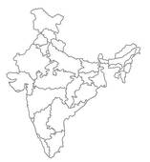

** THE END **

