 | KENDRIYA VIDYALAYA SANGATHAN
 | SUMMATIVE ASSESSMENT- II (Kurnool Cluster)
 | CLASS: III SEC: ____ Total No. of pages:07 Max Marks : 60
 | SUB: ENGLISH |  |  | TIME: 2 hours |  |  | DATE: ____________
NAME: _________________________________________________________. |  |  |  |  |  |  |  |  | ROLL NO : _____
COMPETENCIES |  | READING  (20VP) | WRITING |  |  |  |  |  |  |  | OVER ALL  (60VP)
 |  |  | TEXT  (10VP) |  | GRAMMAR  (10VP) | CREATIVE WRITING  (10VP) |  | SPELLING  (5VP) |  | HAND-WRITING  (5VP)
Value points
GRADES
Signature of Invigilator : ________________ |  |  |  |  |  | Signature of Evaluator : ________________

READING:-
- Read the given passage carefully and answer the following questions:-
On the 16 th of June 1730 we discovered land. Our captain sent a dozen men with vessels for water, if any could be found. When we came to land we saw no river or spring nor any inhabitants. I went on to explore. The country was barren and rocky. I turned back to join the crew, only to see them getting into the boat and rowing for life to get to the ship. Before I could reach them I observed a huge creature walking after them in the sea as fast as he could. The water of the ocean reached only till his knees.
1. When was the land was discovered?
A)……………………………………………………………………………………………………………………
2. How many people did the captain send?
A)……………………………………………………………………………………………………………………
3. Why did the captain send the men?
A)……………………………………………………………………………………………………………………
4. How was the country when they came to the land?
A)……………………………………………………………………………………………………………………
5. To whom did he join after turning back?
A)……………………………………………………………………………………………………………………
6. What did he observe?
A)……………………………………………………………………………………………………………………
7. What is the meaning of the word ‘Dozen men’ in the passage? Underline the correct answer.
(a) 5 members (b) 8 members (c) 9 members (d) 12 members
8. What is the meaning of the word ‘Huge’ in the given passage? Underline it.
(a) very small (b) very big (c) small (d) big
9. Write the Past tense for the action word ‘Reach’: ………………………………………
10.Write the Present tense for the word ‘Observed’ :……………………………….......
B.Read the given passage carefully and answer the following questions:- (10VP)
Once upon a time, four cows lived in a jungle. They were fast friends. They were always together. They lived in peace. If any wild animal ever attacked them, all the four of them fought the enemy united and drove him away.
A tiger had an eye on these cows. But as long as they were united he did not dare to attack them. The cows fell out one day. Each one went separately her own way. Now the tiger had the opportunity that he was looking for. He killed the cows one by one and ate them up.
Moral: Unity is strength.
1. Who lived in a jungle?
Ans.____________________________________________________________
2. How did they live?
Ans.____________________________________________________________
3. How did they fight against an enemy?
Ans.____________________________________________________________
4. Who had an eye on them?
Ans.____________________________________________________________
5. Did the tiger dare to attack them when they were united?
Ans.____________________________________________________________
6. Finally, when did the tiger attack them?
Ans.____________________________________________________________
7. What is the moral of this story?
Ans.____________________________________________________________
8. Write the opposites for
(a) Friend -- …………………… (b) Long -- ……………………..
9. Write the Present tense for the verb ‘Fought’ ………………………..
Answer the following questions:- (2x5=10VP)1.What kind of child was Sanatombi?
Ans)………………………………………………………………………………………………………………………………………………………………………………………………………………………………………
2. Where did Malu want to travel?
Ans)………………………………………………………………………………………………………………………………………………………………………………………………………………………………………
3. Why did the train stop the first time?
Ans)……………………………………………………………………………………………………………………………………………………………………………………………………………………………………………………………………………………………………………………………………………………………
4. Why did the men rush back to the ship?
Ans)…………………………………………………………………………………………………………………………………………………………………………………………………………………………………………………………………………………………………………………………………………………………………………
5. Why did the Barber want a lot of food?
Ans)…………………………………………………………………………………………………………………………………………………………………………………………………………………………………………………………………………………………………………………………………………………………………………..
GRAMMAR:- (10VP)
(A)Fill in the blanks with suitable Articles (a, an or the):- (1X2=2VP)
1. Ramesh was …………………… unpopular boy.
2. As the summer came ………………… pond began to get dried up.
(B) Compare the two or three things/ people by adding “—er, --est” for the following sentences :( 1x4=4VP)
1. (a) Ravi is my good friend.
(b) Raju is my …………………. friend than Ravi.
(c) Rama is the …………………… friend of all.
2. (a)Iron is a ……………………………….. metal.
(b) Silver is brighter than Iron.
(c )Gold is the ………………………………… of all metals.
- Write the Present Tense or Past Tense for the following words:- (1x2=2VP)

S.No | Present Tense | Past Tense
1. | Say
2. |  | Thought

(C)Fill in the blanks with suitable Prepositions given in the brackets.(of, in, under, with) (2VP)
1. Teacher is writing ………………………………….. a chalk on the black board.
2. The man stood ………………………… the tree.
CREATIVE WRITING:
(a)Describe your close friend by using the following clues given in the brackets.
(good, very helpful, share the feelings, studious, naughty, generous, hard worker, clever)
Ans) My best friend is ……………………………………………...........................................................................
………………………………………………………………………………………………………………………
………………………………………………………………………………………………………………………
………………………………………………………………………………………………………………………
………………………………………………………………………………………………………………………
………………………………………………………………………………………………………………………
………………………………………………………………………………………………………………………
(B)Write the Picture Composition by observing the following picture and also clues are also have been given in the brackets:
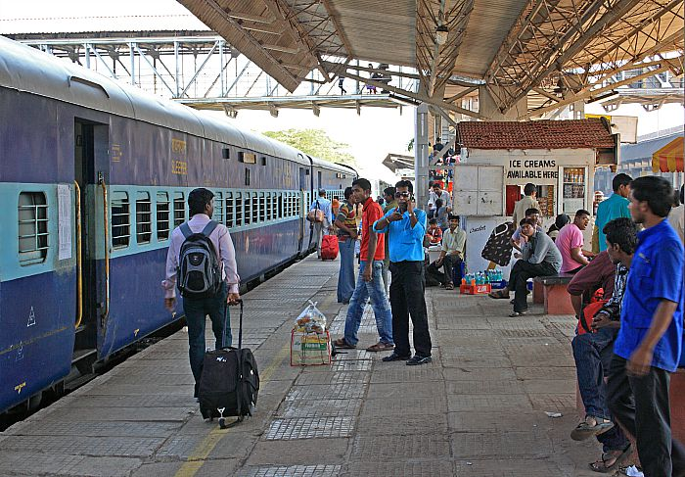
(railway station, passengers, getting into the train, tea stall, cooli, carrying luggage, a boy sleeping on the floor, a beggar begging money)

Ans)……………………………………………………………………………………………………………………
…………………………………………………………………………………………………………………………
…………………………………………………………………………………………………………………………
…………………………………………………………………………………………………………………………
…………………………………………………………………………………………………………………………
…………………………………………………………………………………………………………………………
…………………………………………………………………………………………………………………………
……………………………………………………………………………………………………
SPELLING:- (5VP) Complete the missing letters in the given words: (1x3=3VP)
1.(a)Tr____ve____l ___er (b) C ___nd ____ ct ____r (c) Pr _____c ____ss _____on
2. Frame any Two (2) new words from the given word ‘DISCUSSION’
(a)………………………………. (b)……………………………
HAND WRITING:
Rewrite the given passage neatly in cursive hand writing : (5VP)
Only a healthy man can be happy .If the body is healthy, the mind will also be healthy. A healthy mind is a happy mind. If we are cheerful, we can do our work with enthusiasm. We will then be successful in all that we do. Thus good health is the strong foundation on which success and prosperity can be built up.
Ans)…………………………………………………………………………………………………………………………………………………………………………………………………………………………………………………………………………………………………………………………………………………………………………………………………………………………………………………………………………………………………………………………………………………………………………………………………………………………………………………………………………………………………………………………………………………………………………………………………………………………………………………………………………………
The End

